How To Know When a Doe is a Doe
As each winter season approaches, it seems as though those gorgeous and rugged Bucks adorned with sprawling antlers disappear….or do they?
Although a bachelor’s trip down to Florida sure sounds like a fun idea, the Bucks don’t actually go anywhere. They do, however, shed their antlers during the winter months. This yearly cycle can make it difficult to discern Does from Bucks during these months, as without the antlers, they all appear to be Does to the untrained eye. In addition, young Bucks approaching maturity can also have a more feminine appearance without their antlers.
Here are some tips in helping to identify & differentiate the girls from the boys:
- Appearance

  - Body shape & size
    - Does are tall and rectangular in shape with a longer profile, often having a more full appearance in the abdominal area than Bucks.
    - Bucks are typically larger and broader than females, but may exhibit a more slender abdominal area (especially during seasons where Does are likely pregnant)
    - Fawn and Yearling Bucks have a more square, stumpy body profile, as they are still growing.

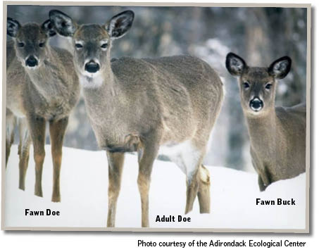
  - Head shape & size
    - Adult Does typically have a rounded head between the ears, with elongated neck and nose.
    - Adult Bucks have a flattened head shape, particularly at the base of antler insertion, and a thicker neck. Bucks will always have bony “buttons” where their antlers grow from- by using binoculars this is a tell-tale trait to observe.
    - Fawns and Juveniles have a “fluffier” appearance, which smaller square-shaped heads and shorter neck.
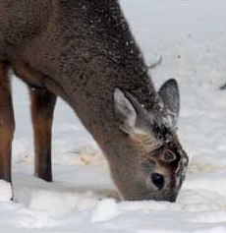
In the above photo, note the rounded appearance of the does’ heads, and the flat appearance of the head of the fawn buck.

In both photos to the left, you will notice the “buttons” at antler growth sites, along with thicker neck girth. Photos courtesy of rippleoutdoors.com.

- Behavior

  - Cautious and Alert? Likely a trait you’ll see with Does over Bucks.

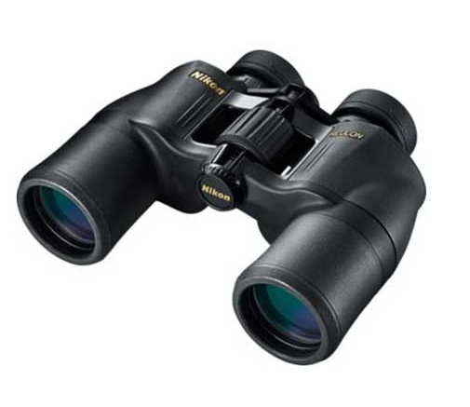
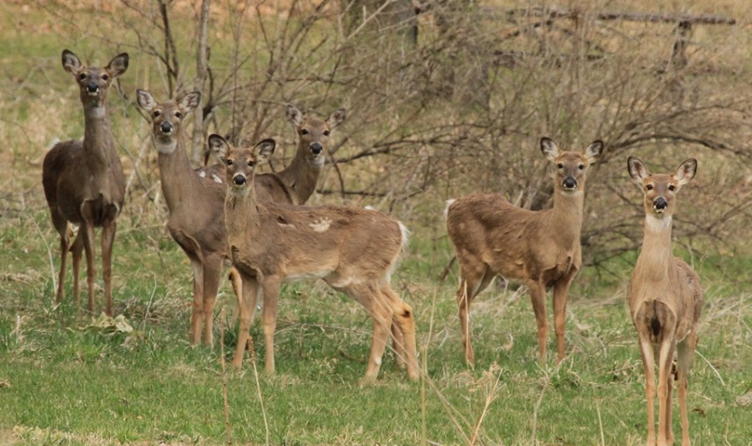
  - Most Does will travel in herds with other deer, so when adult aged animals are spotted alone, the chances of the animal being a male are high.

Group of female deer. Photo: randyroberts.wordpress.com

Your best bet in determining Does from Bucks is to have set of binoculars handy so that you can really get a good look at their head shape and presence of antler buttons.

